Heroes Welcome in London is jointly sponsored by the
London Evening Standard and Black Cab Driver Associations, with the kind permission of Transport for London our aim is to try to get a Heroes Welcome sticker displayed in every London Cab.

Dear Black Cab Drivers

Heroes Welcome in London
London is launching a Heroes Welcome scheme and by doing so is joining a network of Towns, Cities Counties and Crown Territories from across the United Kingdom and beyond, who all wish to show their open support to members of the British Armed Forces and do so 365 days of the year!

Whilst Heroes Welcome is not a charity or a discount scheme, it does provide a free and simple method for your business, be it a service provider, cafe, pub, shop, restaurant, hotel, or taxi, to show a little special appreciation to those serving in the Armed Forces and do it in a way that is effective and appropriate. All we ask is that if you display a Heroes Welcome sticker then you agree to give a special warm welcome to members of the Armed Forces. You may also wish to offer a small discount or service upgrade but that is up to you.

By way of proof, all Service Personnel carry a clearly marked Military ID Card.

Joining Up Is Free and As Easy As 1-2-3
1. Pick up the free sticker and peel off the backing paper.
2. Display your HW sticker in your taxi’s nearside rear quarter light / or shop window with pride and Smile.
3. Decide whether or not you wish to offer a service upgrade or small discount.

NB Transport for London has given permission for the Heroes Welcome Window sticker to be displayed in the nearside rear quarter light window.
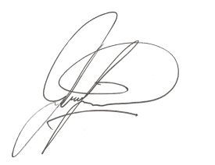
Your display of support is very much appreciated by those serving at home and abroad.

Yours sincerely
John W Senior TD
National Co-ordinator

“To see a full rank of York Taxis proudly bearing their Heroes Welcome stickers with pride brought a tear to my eye!” Lt Col T Gray Coldstream Guards

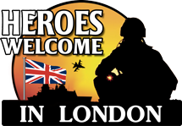
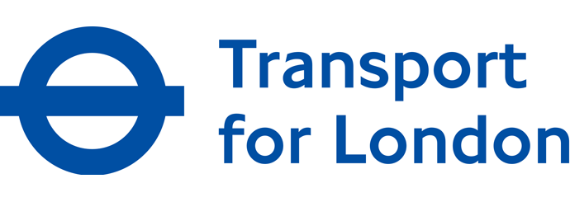

For further information or contact details please see: www.heroeswelcome.co.uk

